IMMACULATE CONCEPTION CATHOLIC CHURCH, SOUTHAMPTON
PREPARATION FOR THE SACRAMENT OF CONFIRMATION 2024
REGISTRATION FORM

Name
Address
E mail
Phone No
Nationality
Which church do you regularly attend?

Have you already been baptised in a Catholic Church?
YES | NO
Where were you baptised? | Were you baptised in another Christian church? YES / NO
Please attach a copy of your baptism certificate | If YES where were you baptised?
Have you made your First Confession?  YES / NO | Please attach a copy of your baptism certificate
Have you made your First Holy Communion?

YES / NO

If you are under 18: | (PARENTAL CONSENT FORM OVERLEAF SHOULD ALSO BE COMPLETED)
- Date of birth
- School/College
- Parents Name
- Parents E mail
- Parents phone number

FEE: We charge a minimal fee of £25 to cover our costs incurred. This can be paid in cash or on line. Account details as follows:
Account Name: PRDCT Immaculate Conception
Sort Code: 30-93-04 Account No: 0887995 Please use ref: Confirmation
Please tick below:
I am paying in cash
I have paid online
Information provided on this form, together with all other personal data held about these individuals by the Parish and the Diocese of Portsmouth, is processed in accordance with the Diocese's Privacy Notice, which can be obtained from www.portsmouthdiocese.org.uk/gdpr
Signature ………………………………………………………………………………………………..… Date: ………………

If under 18
Signature of parent or guardian ………………………………………………………………… Date: ………………….

Confirmation 2021-22
Parental Consent for young people under age 18

Name of Child: …………………………………………………………………….

Name of Parent/Carer: ………………………………………………………..

Please let us know about any health conditions, medication, allergies or particular needs you think we should be aware of.

When the session is finished how will your child get home? (please tick appropriate box)

- I will collect my child

- (Name) _________________________ will collect my child

- I am happy for my child to make his/her own way home

PARENT/GUARDIAN CONSENT FOR THE USE OF PHOTOGRAPHS/VIDEOS

During the course we may occasionally take photographs of the participants. We may use these images for our website or Diocesan publications. We may also make video or webcam recordings for Diocesan use only. In accordance with the diocesan child protection policy and to comply with the Data Protection Act 1998, we need your permission before we can photograph or make any recordings of your child for promotional purposes.

May we use your child’s photograph in printed publications that we produce for promotional purposes? | Yes/No
May we use your child’s images on our website? | Yes/No
May we record your child’s images on video or webcam? | Yes/No
Are you happy for your child to appear in the media? | Yes/No

Parent Signature: Date:

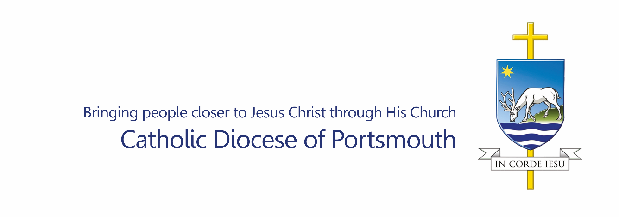Consent to the Use of Images (Photography and Filming)
for ages 18 and above
INTRODUCTION
The Catholic Diocese of Portsmouth is committed to ensuring all communications about or featuring photographic or film/video footage are created and disseminated with professionalism, sensitivity and with due regard to rights of dignity, privacy and confidentiality.
Images are regularly used in Diocesan publications across print and digital channels and social media tools for distribution across the Diocese of Portsmouth, nationally and internationally. These publications regularly feature adults, and young people, aged 18 years and above, recognising their worth and abilities; and are used for specific promotional purposes in support of the Diocesan Mission. Images will be retained securely by the Diocese up to six years, electronically or in paper format.
INFORMATION PROVIDED ON THIS FORM, TOGETHER WITH ALL PERSONAL DATA HELD ABOUT THESE INDIVIDUALS BY THE PARISH AND THE CATHOLIC DIOCESE OF PORTSMOUTH, IS PROCESSED IN ACCORDANCE WITH THE DIOCESE’S PRIVACY NOTICE. OVERLEAF IS A PRIVACY NOTICE RELEVANT TO THIS CONSENT FOR THE USE OF IMAGES FORM www.portsmouthdiocese.org.uk/privacynotice
CONSENT FOR USE OF IMAGE(S) FOR AGES 18 AND ABOVE
I GIVE MY CONSENT TO MY IMAGE(S) BEING TAKEN, USED, AND STORED AS DESCRIBED ABOVE:-

NAME:- ....................................................................
ADDRESS WITH POSTCODE:- ......................................................................................................
……………………………………………………………………………………………………………………………………………….

SIGNED:-...................... DATE:- ....................

PLEASE DO NOT USE MY NAME ALONGSIDE ANY USE OF THESE PHOTOGRAPHS: ☐

I UNDERSTAND I CAN WITHDRAW CONSENT AT ANY TIME WITHOUT EXPLANATION: ☐

FULL DETAILS OF THE GENERAL DATA PROTECTION REGULATION PRIVACY NOTICE FOR THE USE OF PHOTOGRAPHIC AND FILM IMAGES CAN BE FOUND AT: https://www.portsmouthdiocese.org.uk/gdpr

